Assignment 3 :

- GitHub Link :
- README.md Link :

Design and Simulate 4-bit BCD to Excess-3 code converter using Verilog HDL and verify its operation through simulation.

Verilog code :
module bcd_to_excess_3_dataflow (
input [3:0] bcd,
output [3:0] excess_3
);

assign excess_3 = bcd + 4'b0011;

endmodule
Compilation :

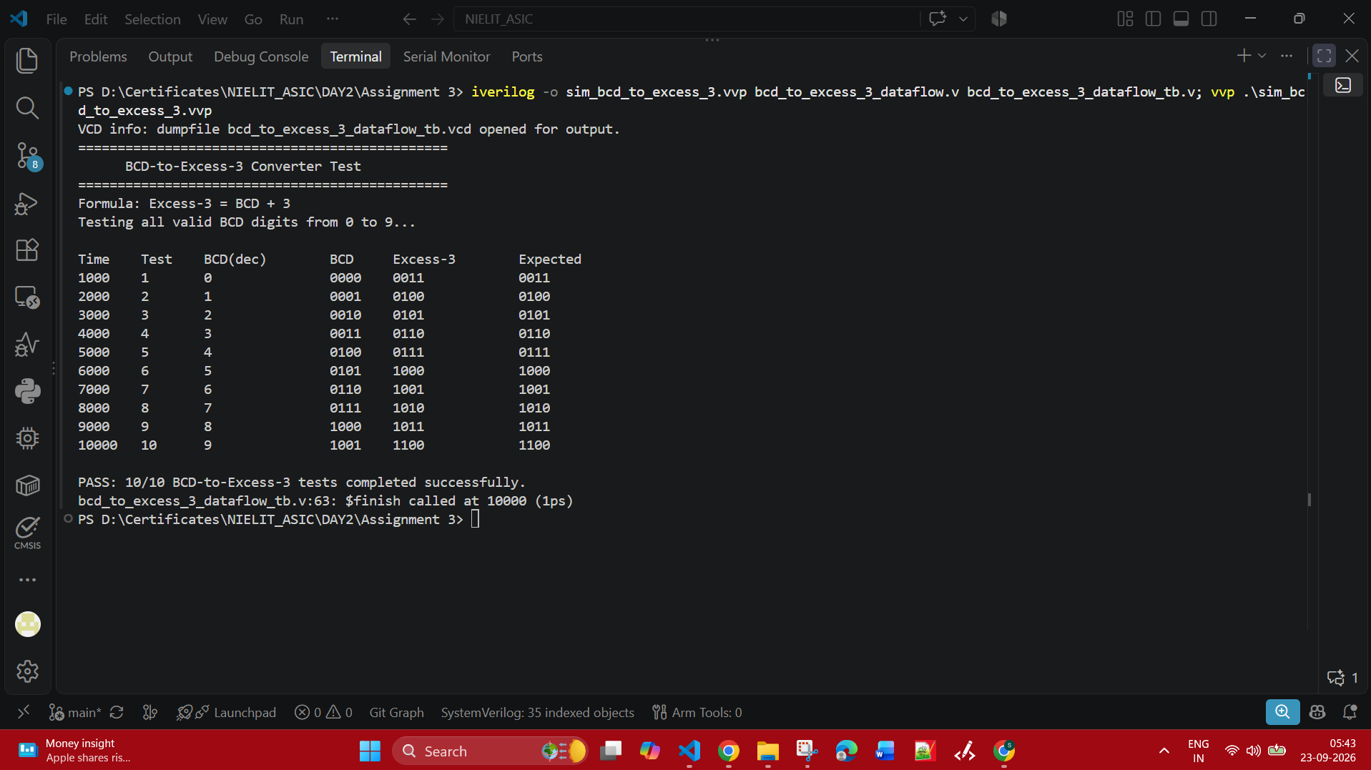

Simulation :

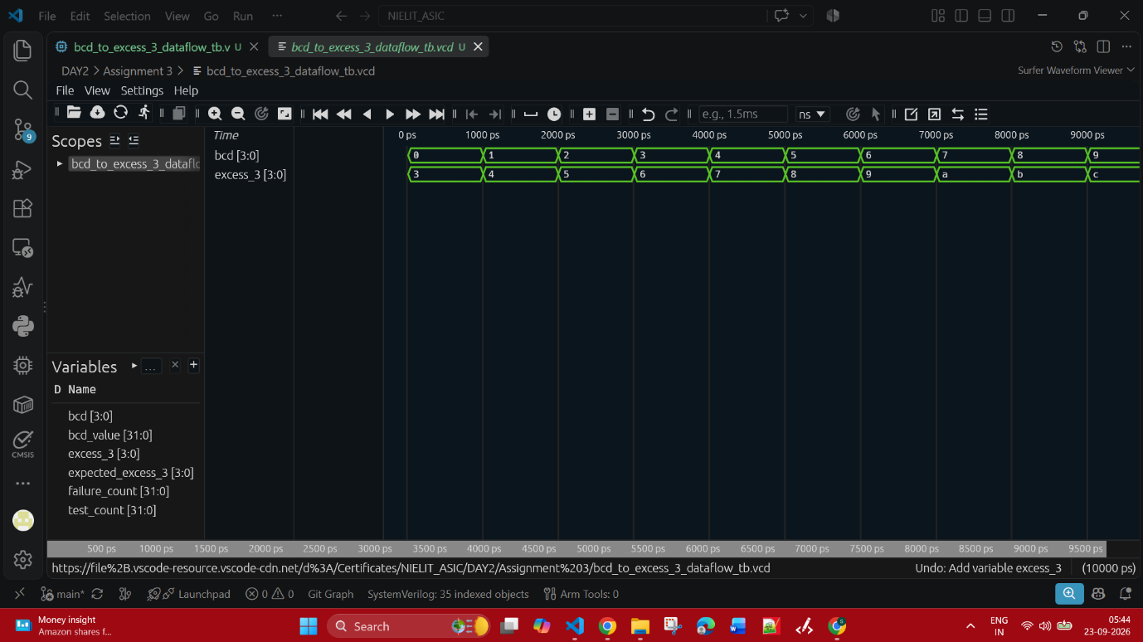

- Design and simulate a Verilog module that converts a 4-bit BCD input into the corresponding seven segment display outputs.

Verilog code :
module bcd_to_seven_segment_dataflow (
input [3:0] bcd,
output reg [6:0] segment
);

always @(*) begin
case (bcd)
4'd0: segment = 7'b0111111;
4'd1: segment = 7'b0000110;
4'd2: segment = 7'b1011011;
4'd3: segment = 7'b1001111;
4'd4: segment = 7'b1100110;
4'd5: segment = 7'b1101101;
4'd6: segment = 7'b1111101;
4'd7: segment = 7'b0000111;
4'd8: segment = 7'b1111111;
4'd9: segment = 7'b1101111;
default: segment = 7'b0000000;
endcase
end

endmodule

Compilation :

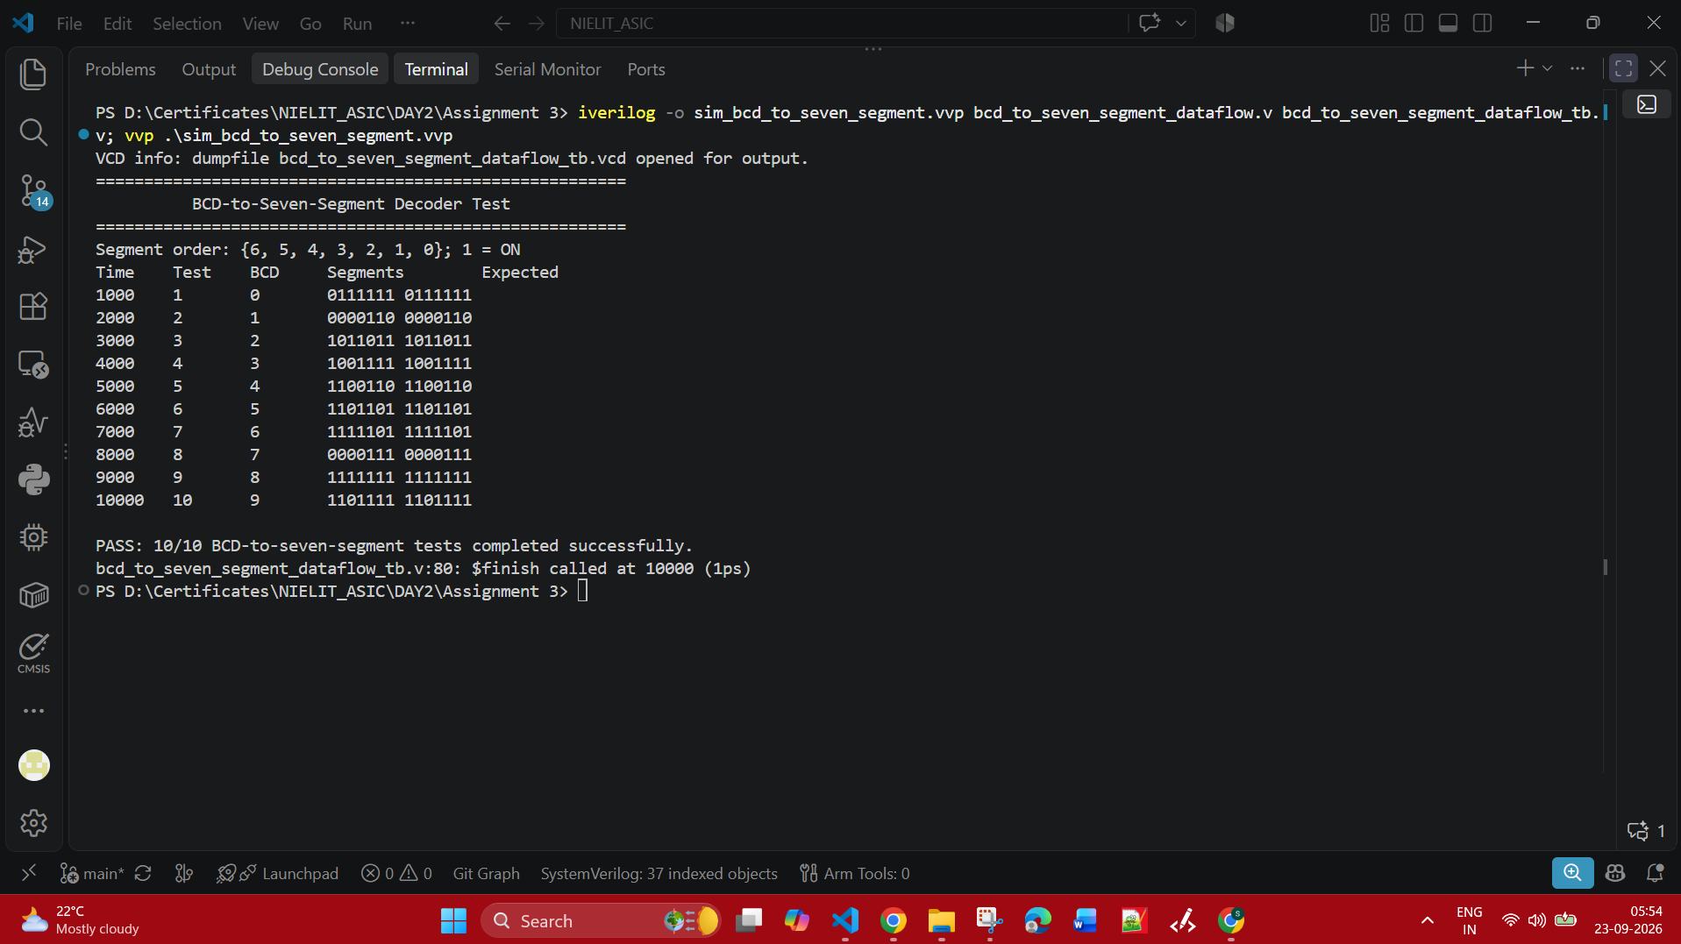

Simulation :

